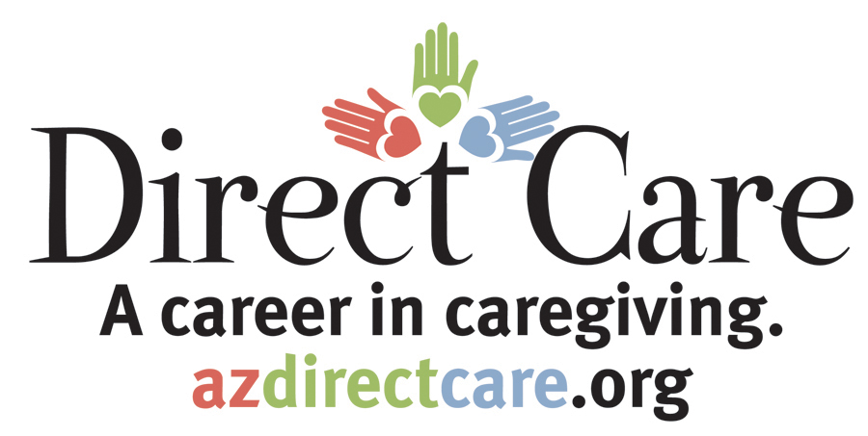
Arizona
Direct Care Worker
Training

This certificate of completion is awarded to

Level 2: Aging and Physical Disabilities

By:

Instructor |  | Date

